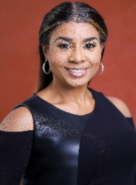
TAMIKO RACHELLE 443-682-4242

NON-UNION soldbytamiko@gmail.com

HEIGHT: 5’2” W

HEIGHT: 5’2” WEIGHT: 145 HAIR: DARK BROWN/AUBURN EYES: BROWN

FILM
A HUSTLER’S SON 2 Supporting Actor Cartel Urban Cinema/T. Styles
A HUSTLER’S SON Supporting Actor Cartel Urban Cinema/T. Styles
CAROUSEL Non-Speaking Actor Undisclosed
SMACK Non-Speaking Actor Wet Paint Pictures/Alice Bozga

TELEVISION
MAYOR OF KINGSTOWN Background Actor Paramount/Tasha Smith, Director
BB MAKE UP WARS Host Bavarlee Bernstein Productions
YOUR NEW HOME Host Chosen Media
LIVE Background Actor HBO

COMMERICAL
ANGI Principal Actor Bonfire Labs, V. Appleton, Director

THEATRE
THE MAN MONSTER Supporting Actor T. Renee Garner Prod/Kristen Young/Director

SPECIAL SKILLS
DIALECTS: US-East Coast, Southern, New York (Bronx), Spanish accents
SKILLS: Singing, Dancing, Modeling, Hosting, Culinary Arts, Green Screen

